

**INTERNATIONAL SCHOOL**

**CAPSTONE PROJECT 2**

**What should I eat today?**

PROPOSAL DOCUMENT

Version 1.0

**Mentor** : Nguyen Thi Bao Trang

**Name Team** : 101dogS Team

**Team Member** : Le Nguyen Hoang Van

Luong Minh Hieu

Nguyen Dinh Luu

Tran Quang Khai

Da Nang, 02/17/2020

|  |  |  |  |  |
| --- | --- | --- | --- | --- |
| **Project acronym** | WIET | | | |
| **Project Title** | **What should I eat today?** | | | |
| **Start Date** | 02/12/2020 | **End Date** | 05/15/2020 | |
| **Lead Institution** | International School, Duy Tan University | | | |
| **Project Mentor** | Nguyen Thi Bao Trang | | | |
| **Team members** | **Name** | **Email** | | **Tel** |
| Le Nguyen Hoang Van | lenguyenhoangvan18@gmail.com | | 0935604934 |
| Luong Minh Hieu | minhhieudn98@gmail.com | | 0399870055 |
| Nguyen Dinh Luu | dinhluu098@gmail.com | | 0935883503 |
| Tran Quang Khai | tquangkhai98@gmail.com | | 0976308098 |

**PROJECT INFORMATION**

**DOCUMENT HISTORY**

|  |  |  |  |
| --- | --- | --- | --- |
| **Version** | **Date** | **Comments** | **Person** |
| 1.0 | 02/18/2020 | Draft for comment | Le N. H. Van |

**Document Approval**

|  |  |  |
| --- | --- | --- |
| Trang, Nguyen Thi Bao  *Mentor* |  | **Date:** |
| Van, Le Nguyen Hoang  *Scrum Master* |  | **Date:** |
| Hieu, Luong Minh  *Member* |  | **Date:** |
| Luu, Nguyen Dinh  *Member* |  | **Date:** |
| Khai, Quang Tran  *Member* |  | **Date:** |

Table of Contents

**1** **INTRODUCTION TO THE PROPOSAL DOCUMENT** 5

***1.1*** ***Purpose*** 5

***1.2*** ***Scope*** 5

***1.3*** ***References*** 5

**2** **PROJECT OUTLINE** 6

***2.1*** ***Project Overview*** 6

***2.2*** ***Business needs*** 6

***2.3*** ***Prior Art*** 6

***2.4*** ***Proposed Solution*** 6

**2.4.1** **Project Goal** 6

**2.4.2** **System Overview** 7

**2.4.3** **Constraints** 8

***2.5*** ***Purpose*** 8

***2.6*** ***Process*** 8

**2.6.1** **Why chooses Scrum?** 8

**2.6.2** **Scrum Process** 9

**3** **ESTIMATION AND MILESTONES** 10

**3.1** **Estimation Schedule** 10

**3.2** **Cost estimate** 11

**3.2.1** **Role** 11

**3.2.2** **Cost Person/Hours** 11

**4** **PROBLEM SOLVING.** **Error! Bookmark not defined.**

**5** **WORK ENVIRONMENT.** **Error! Bookmark not defined.**

# **INTRODUCTION TO THE PROPOSAL DOCUMENT**

## ***Purpose***

* The document provides an overview of the project includes the purpose and scope of project.
* In addition, identify business needs, problems or situation related to the initialization and construction projects.
* Provide solution for business needs and give the overview of system architecture.
* Provide overview about resources, schedule, risk, solution and budget for the project.

## ***Scope***

* This document provides an overview of project will be developed. It includes overview of the product, overview of the process and overview of the project team.
* This document provides a plan for each stage of software development process based on Scrum process include start time, end time and number of working days. This is the general plan and will be updated with detail of the software development process in the next version of document. Proposal includes the introduction of solutions; determine the best way to develop software that we make the total estimated costs, payback period, and break-even volume for the project.

## ***References***

|  |  |  |
| --- | --- | --- |
| **No.** | **References** | **Document Information** |
| 1 | **Scrum process** | <https://www.guru99.com/agile-scrum-extreme-testing.html> |
| 2 | **Technical** | <https://stackoverflow.com/> |
|  |  | <https://developer.android.com/guide> |
|  |  | <https://www.tutorialspoint.com> |
| 3 | **Information** | [https://foody.vn/](https://myswimpro.com/) |
|  |  | [https://rapidapi.com/category/Food](https://myswimpro.com/)/ |
|  |  | [https://en.wikipedia.org/](https://en.wikipedia.org/wiki/Swimming_(sport)) |

# **PROJECT OVERVIEW**

## ***Project Definition***

To build a system named “WIET” based requirements that include an android mobile application, which can help users decided what they want to eat today, then find the location of restaurants or food ingredients.

## ***Business needs and user needs***

### **Issue description:**

My customers said that: “Sometimes, ah not, it's always with me... We don't know what we should to eat for breakfast, lunch and also dinner. So, we can make a random app and get data from foody or other apps and generate random dishes for breakfast, lunch, dinner. It's not easy here, we should implement Machine Learning for this, which type of food the users want to use, base on that, we can recommend the correct one. Knowing the reflection of the users.” So, our team decide to make an android mobile application that can solve these problems.

### **Business needs:**

The “WIET” will benefits:

* Helps users a lot in decide which food they want to eat.
* Helps users find location of restaurants.
* Helps users find ingredient of dishes.

## ***Prior Art***

Nowadays, there are many applications that help users find and booking food. But there are no applications which help users decided which they want the most, and help them at the market.

*Example:*

* Foody at address website <https://foody.com/>
* Now application for mobile.
* Grab application for mobile.

## ***Proposed Solution***

* Our team recommend building a “WIET” mobile application with full features for users.
* Our team members work based on the requirements and come up with solutions and project implementation.
* Our application is an android mobile application.
* Help users decide which dishes they want to eat.
* Help users find location of restaurant immediately.
* Help vegetarian users.

### **Project Goal**

The goal of project is to build the “WIET” android application with many functions that help users decide which dishes they want to eat. The system also helps users find location of restaurant immediately. And if they are in the market, the system helps they which ingredients for their dishes. If you are a vegetarian, we also have dishes for you. Additionally, with a friendly user interface, we will make user have better experience when using.

### **System Overview**

#### **System Context Overview**

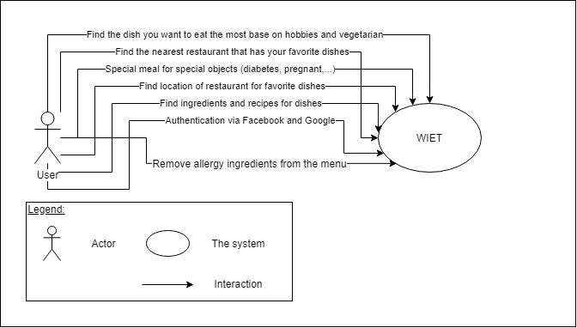

***Figure 1: Context Diagram***

#### **System Context Description**

* Users have the responsibilities to:
  + Find the dish that users want to eat the most base on hobbies and vegetarian.
  + Find the nearest restaurant that has users favorite dishes.
  + Special meal for special object. (diabetes, pregnant,…)
  + Find location of restaurant for favorite dishes.
  + Authentication via Facebook or Google.
  + Remove allergy ingredients from the menu.

### **Constraints**

#### **Business Constraints**

* *License & Copyright*
  + Icon, frame and texture picture will somehow violate the copyright.
* *Boundary*
  + For Vietnamese peoples.

#### **Technical Constraints**

* *Technologies:*
  + Languages: Java, Python.
  + Database: PostgreSQL.
* *Operating Environment:*
  + Mobile Android Operator.
* *Framework /Libraries:*
  + Flask

#### **Project Constraints**

* Schedule: Project will be finished by Dec 10th, 2019.
* Team Composition:
  + Team formation is 4 and each person has each pros and cons.
  + Most of team member’s con is technical.
  + Lack of experiences.
  + A total of 8 hours working a day.
  + 5 working days a week.

## ***Purpose***

Create an application that help user easier find what and where they want to eat. Or if they want to eat at home, we would recommend ingredients of their favorite food for them.

## ***Process***

### **Why chooses Scrum?**

Traditional waterfall is being used a lot of time before Scrum will bring PORO a new way to implement software.

Scrum allows team to learn by doing, focus on practical not theory oriented.

Scrum is a flexible method to implement a software so that we can actually work as if there are some changes in the software.

Scrum allows us to not focus too much on plan but planning and doing at the same time.

Scrum helps to minimum documentation process.

### **Scrum Process**

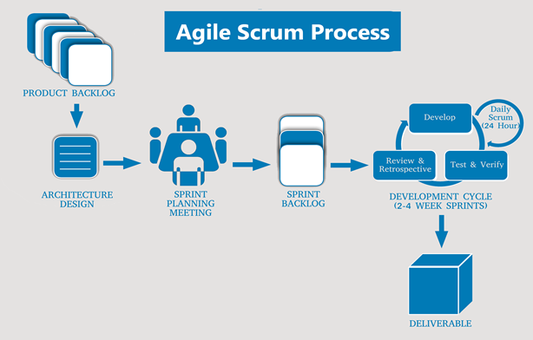

* Scrum is an iterative and incremental agile software development framework for managing software projects and product or application development.
* Scrum focuses on project management institutions where it is difficult to plan ahead.
* Mechanisms of empirical process control, where feedback loops that constitute the core management technique are used as opposed to traditional command-and-control management.
* Its approach to planning and managing projects is by bringing decision-making authority to the level of operation properties and certainties.
* Benefit of the methodology:
  + Project can respond easily to change.
  + Problems are identified early.
  + Customer gets most beneficial work first.
  + Work done will better meet the customer’s needs.
  + Improved productivity.
  + Ability to maintain a predictable schedule for delivery.

# **ESTIMATION AND MILESTONES**

## **Estimation Schedule**

|  |  |  |  |  |
| --- | --- | --- | --- | --- |
| **NO** | **Task Name** | **Duration** | **Start** | **Finish** |
| **1** | ***Initial*** | ***1 days*** | ***02/14/2020*** | ***02/14/2020*** |
| 1.2 | *Project Kick-off Meeting* | *1 days* | *02/14/2020* | *02/14/2020* |
| **2** | ***Start Up*** | ***1 days*** | ***02/17/2020*** | ***02/17/2020*** |
| 2.1 | *Create Proposal Document* | *1 days* | *02/17/2020* | *02/17/2020* |
| **3** | ***Development*** | ***84 days*** | ***02/18/2020*** | ***05/12/2020*** |
| 3.1 | *Sprint 1* | *14 days* | *02/18/2020* | *03/03/2020* |
| 3.2 | *Sprint 2* | *14 days* | *03/03/2020* | *03/17/2020* |
| 3.3 | *Sprint 3* | *14 days* | 03/17/2020 | 03/31/2020 |
| 3.4 | *Sprint 4* | *14 days* | *03/31/2020* | *04/14/2020* |
| 3.5 | *Sprint 5* | *14 days* | *04/14/2020* | *04/28/2020* |
| 3.6 | *Sprint 6* | *14 days* | *04/28/2020* | *05/12/2020* |
| **4** | ***Final Submission*** | ***2 days*** | ***05/13/2020*** | ***05/15/2020*** |
| **5** | ***Final Release*** | ***1 days*** | ***05/15/2020*** | ***05/15/2020*** |

## **Cost estimate**

### **Role**

|  |  |  |
| --- | --- | --- |
| **Full name** | **Role** | **Salary Rate (USD/hour)** |
| Le Nguyen Hoang Van | Team leader | 1 |
| Luong Minh Hieu | Team member | 1 |
| Nguyen Dinh Luu | Team member | 1 |
| Tran Quang Khai | Team member | 1 |

### **Cost Person/Hours**

|  |  |  |
| --- | --- | --- |
| **No** | **Criteria** | **Total (USD)** |
| 1 | Working hour | $4864 |

* Description:

|  |  |  |
| --- | --- | --- |
| **Description** | **Amount** | **Unit** |
| Number of members | 4 | Person |
| Number of working hours per day | 8 | Hour |
| The cost per member per hour | $2 | USD |
| The duration of the project | 108 | Days |
| The time to use of each computer | 76 | Days |
| The number of working days | 76 | Days |

* Explain:
  + Pc's depreciation = 4 members * USD $1 for maintain/day* 86 days.
  + Amount of working hours = 4 members * 3 hours * 86 days * USD $1/person/hour.